

Newsletter January 2025

22/01/2025

Brinksway School

# **Headteacher’s Welcome**

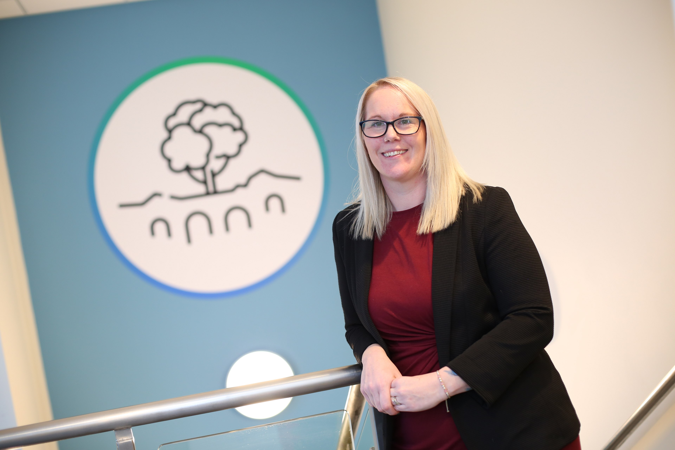

**I hope everyone had a wonderful Christmas and wish you all a Happy New Year.**

**Pupils thoroughly enjoyed getting into the festive spirit in December and engaged in a wide range of activities throughout the half term. As we move forward into the new year, we are focusing on our enrichment offer at Brinksway to provide pupils with more experiential learning experiences.**

# **Attendance**

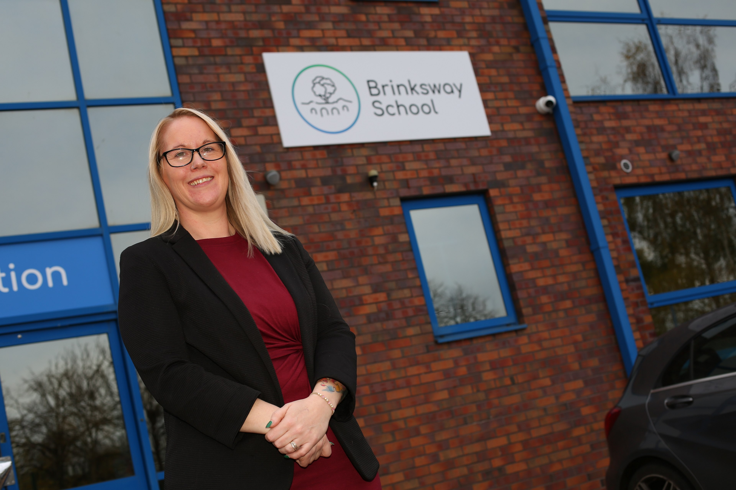

**Attendance is so important to the success of pupils. It creates stability in learning and provides clear routines for our young people. Everyone has a clear part to play in supporting our students to achieve their best and support good attendance. We understand that sometimes there are barriers to this and our pastoral lead Mr Pringle is always available to help and support families, so please do not hesitate to contact us if you need support. Good attendance is classed as 96% or above. We will be promoting this through attendance certificates for good attendance and most improved attendance.**

**Our current whole school attendance sits at 81.7%**

# **Class Names**

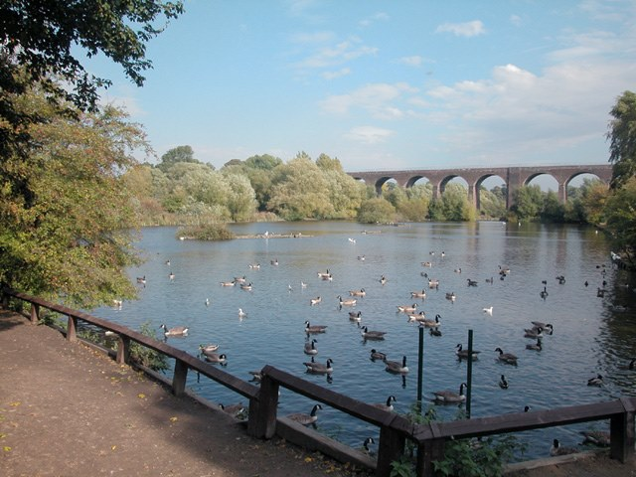

**We have now named our classes. We have chosen to name each class after a local Stockport park.**

1. Etherow – EYFS – Miss McVey
2. Lyme – Key Stage 2 – Miss Christaki
3. Abney- Key Stage 2 – Miss Shah
4. Thornfield –  Key Stage 3 – Mrs Barker
5. Woodbank- Key Stage 3 – Ms Bradshaw

# **Christmas Dinner**

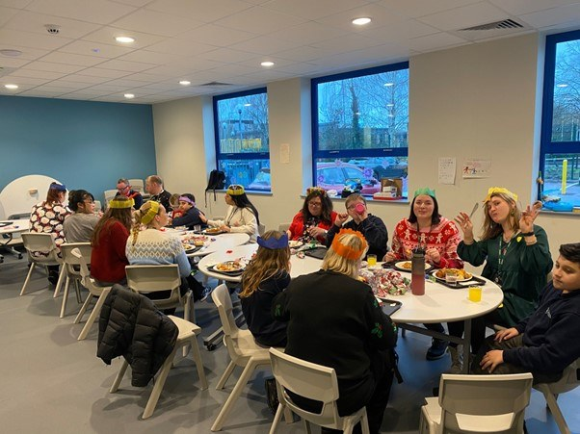

**We enjoyed a wonderful performance by Key Stage 2 of a Christmas song along with sign language whilst enjoying our Christmas dinner. This was such a lovely festive day, with pupils wearing Christmas jumpers, enjoying their activities, lunch and pulling Christmas crackers.**

# **Christmas Santa Visit**

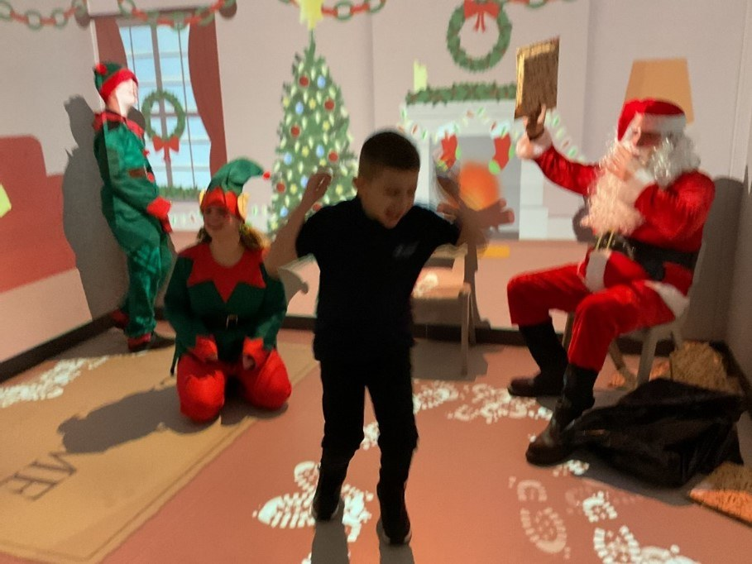

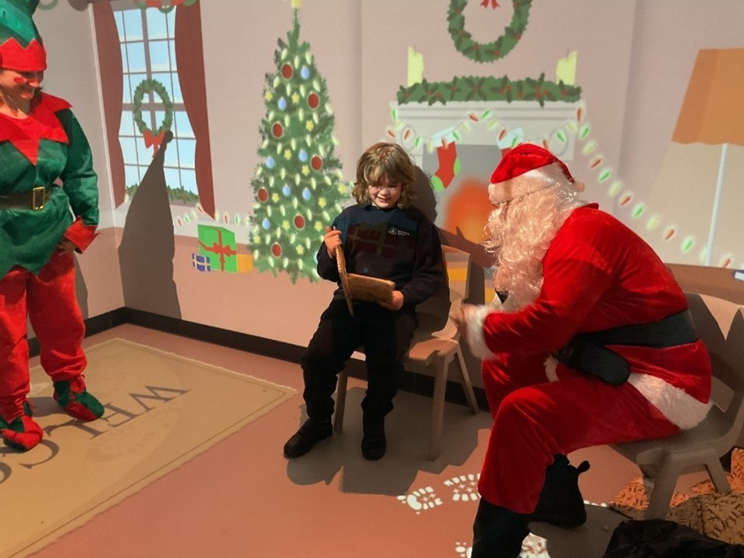

**Pupils were excited when Santa came to visit Brinksway School. Pupils came into Santa’s Grotto and were met by not only Santa, but his helpful elves too. Children enjoyed telling Santa what they would like for Christmas and all received a book as a gift.**

# **Fresh Charity**

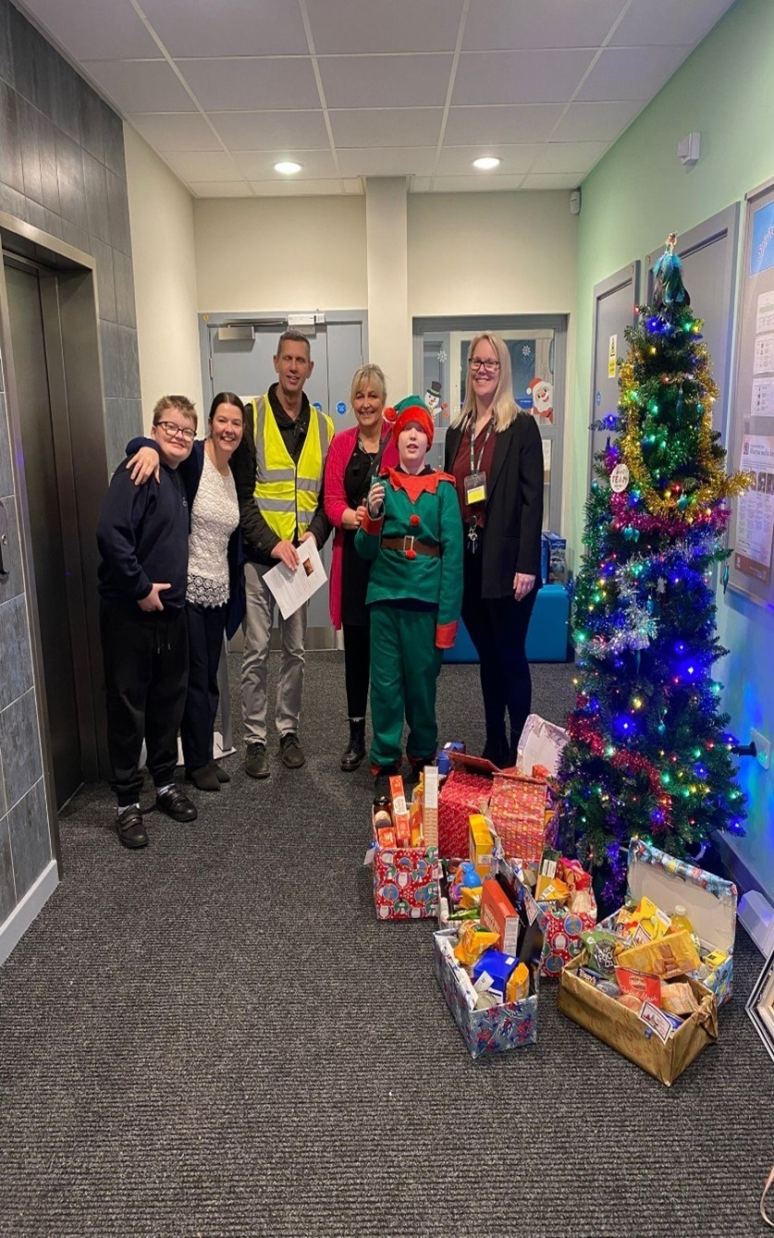

**Thank you so much for your generosity and giving so many donations for those in need. Brinksway School put together 14 donation boxes to Fresh Charity and presented it to one of the charity’s representatives. It was lovely to receive feedback from some of the recipients and see what a difference it made to the community at Christmas.**

# **Animal Therapy**

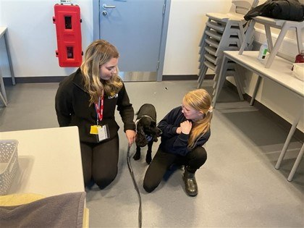

**We have now begun weekly animal sessions, where a range of both furry and scaly creatures are brought in. Each class receives a 30 minute session to meet the animals. Pupils were so calm and caring toward the animals and it was lovely to see how well they engaged with this . As animal therapy continues, pupils will learn more about pet care, habitats and information about the different species they come into contact with**.

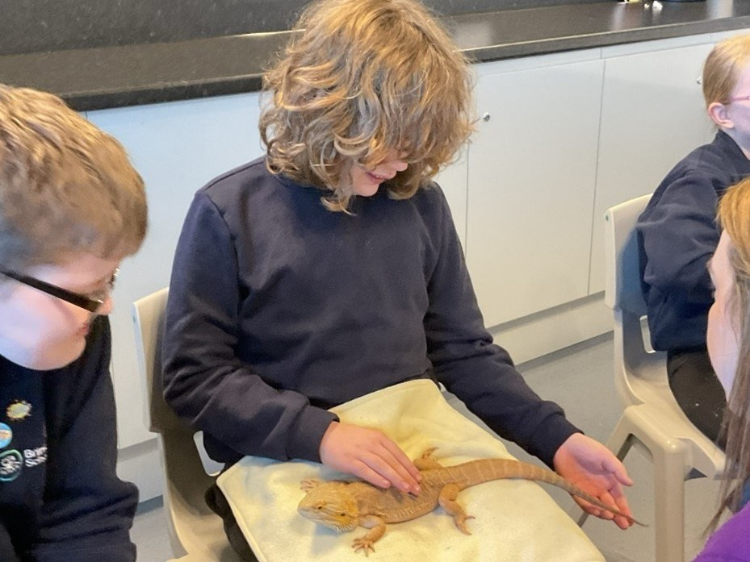

# **EFL parents**

INSPIRE – We have launched our new rewards and behavior policy aimed at supporting our young people to work towards:

I  - Inclusive

N - Nurturing

S - Safe

P - Positivity

I - Independent

R - Respected

E - Enjoy and Engagement

Pupils can earn points daily based on these values, where points are accumulated they can choose from a range of prizes including sensory toys and books. We will also be working toward class reward trips.

# **Library**

**A huge thank you to Aaron Hillson and the Nocutts team for their donation of books to our library. The pupils have thoroughly enjoyed having a range of brand new books to read from during their library visits. We are now setting up a library system which will allow pupils to take books home and check them in and out of the library. Lots of our pupils are also taking home their phonics reading books and it is fantastic to see them develop their love of reading.**

# **Jumpspace**



**As part of our PE and enrichment offer, pupils are visiting Jump Space throughout the year. This is a large soft play and rebound trampolining provision where pupils will have the opportunity to develop their skills in a physical way. There will be a focus on their EHCP targets, turn taking and following instructions.**

**Abney and Lyme class will be attending this half-term, please ensure you fill out the permission forms that were sent home.**

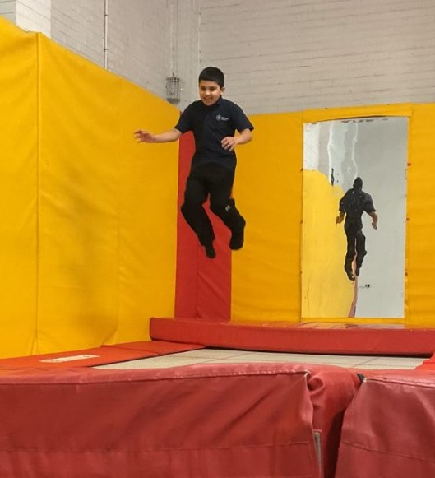

# **Key Dates**

**We invite families to attend our themed coffee mornings over the coming term. These will be a good opportunity for families to meet with other families from our settings and ask meet our team at Brinksway School.**

**If there are any sessions you would like us to cover in upcoming events, please contact the school office.**

**Friday, 14th February**

**9:00-10:00am**

Welcome to Brinksway and meet our team – families invited in to meet the team and meet other families.

**Tuesday, 25th February**

**17:00 – 19:30pm**

Open Evening

We are hosting an open evening for prospective new pupils.

Appointments to view the school can be made by contacting the school office.

**Monday 24th March**

**13:00pm – 14:00pm**

 Disability Stockport talk for families

**Friday, 11th April**

**9:00-10:00am**

Behaviour Strategies and support

**Coffee morning** – Living with autism

Disability Stockport Visit for Families

**We are pleased to host David Wright who is an ambassador for Stockport Disability. We invite families to attend Brinksway School on Monday, March 24th at 1pm where David will talk about his experiences as an autistic adult and how Stockport Disability have supported him to live as independently as possible. You will also have an opportunity to use a VR headset with a specially designed video which emulates the sensory**

**experiences that some of our young people have. David will answer any question you have. Please do let us know if you can attend this session by contacting the office.**

# **Parent View**

**Thank you to those who have responded to the parent view survey. If you could complete the survey (2-3 minutes) this would be extremely appreciated by the school. Your feedback is so important to us.**

<https://forms.office.com/e/3DgnjDeUE1>

**Holiday Dates- The school calendar will be sent out in February outlining school learning days and termly holidays.**

# **Safeguarding**

