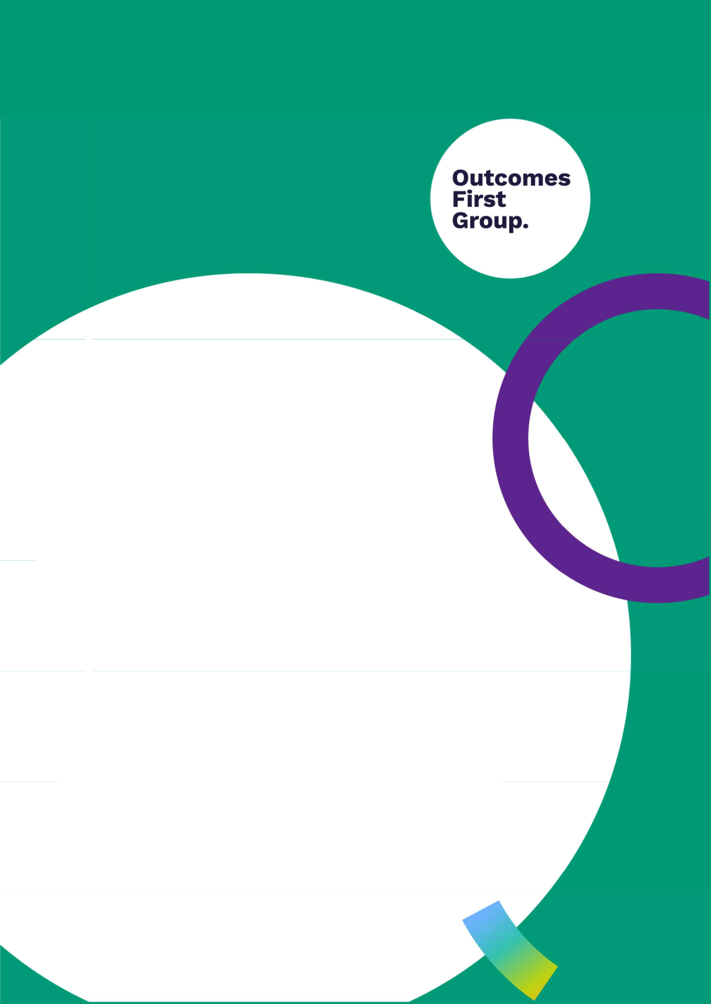

Relationships and

Sex Education Policy

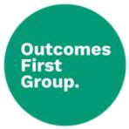
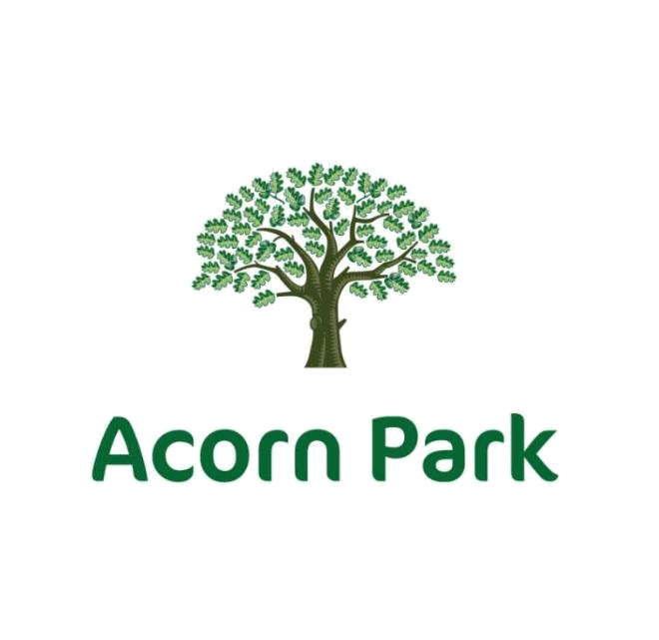



Relationship and Sex Education Policy

Policy Version

V1

Review Date

Sept 2024

Owner

Carla Adams-McCoy

Document Name: Health: Relationships and Sex Education | Version Number: 1.0
Document Type: Policy | Last Review Date: June 2024
Policy Owner: Carla Adams-McCoy | Next Review Date: September 2025
Date First Issued: June 2024

Document History



Version | Comments/Amendments | Name | Date
1 |  | Carla Adams-McCoy | June 2024

Document Name: Health: Relationships and Sex Education | Version Number: 1.0
Document Type: Policy | Last Review Date: June 2024
Policy Owner: Carla Adams-McCoy | Next Review Date: September 2025
Date First Issued: June 2024

Introduction

This policy provides us with a framework for meeting statutory requirements and for achieving the school aims of enhancing students’ knowledge in Relationship and Sex Education (RSE). The school RSE Policy aims to promote pupils’ spiritual, moral, social and cultural development and prepare all pupils for the opportunities, responsibilities and experiences of life.

We are committed to providing a differentiated, broad and balanced programme of RSE education that will benefit all students and to encouraging pupils to develop an enjoyment of this subject.

This RSE policy provides information about the departments policies, objectives and aims and its work which will be helpful to:

- Teaching Staff in the School

- School Leadership Team (SLT)

- Staff Covering RSE lessons

LOCAL AND NATIONAL GUIDANCE:

This policy has been written in consultation with the following guidance:

- PSHE Association guidance document, 2013

- Sex and Relationship Education Guidance (Dfe 0116/2000)

- National Teenage Pregnancy Strategy

- QCA PSHE Curriculum Framework for Schools 2000

- National Curriculum 2000 Statutory Science

- National Healthy Schools Standards 2006

- Ofsted (2002) Sex and Relationships. Office for Standards in Education, London.

Relationships Education, Sex Education and Health Education (RSHE) policy: Policy context and rationale
This relationships, sex and health education policy covers the Brinksway School School approach to teaching relationships, sex and health education (RSHE). This policy has been subject to thorough consultation with the whole-school community including pupils, parents/carers, staff, school governors and where relevant appropriate members of the wider community such as medical professionals and faith leaders. Pupil consultation has ensured that the needs of all pupils can be met through the delivery of an age and stage appropriate RSHE curriculum that addresses relevant issues, informed by analysis of public health data and pupil priorities. Consultation methods have included feedback gathered at the end of sessions. Introduction to the subject meetings and tutorials, written letters sent home, class Dojo messages, individual consultation meetings. Key needs identified were surrounding consideration of trauma and anxiety, and the curriculum was adapted to support these needs where necessary, with parental agreement. Pupil consultation has been used to inform the creation of the school’s RSHE curriculum and this policy where appropriate.

Document Name: Health: Relationships and Sex Education | Version Number: 1.0
Document Type: Policy | Last Review Date: June 2024
Policy Owner: Carla Adams-McCoy | Next Review Date: September 2025
Date First Issued: June 2024

Policy availability

Stakeholders can be informed about the policy through RSHE consultation events via Class Dojo and accessing a copy from the school website. Should a hard-copy of the document be required, the school will be happy to provide this upon request and will also work with any stakeholders that require the policy in an alternative format to meet their individual needs, ensuring equitable accessibility for all. The policy can be obtained in an alternative format by contacting Louisa Barton school administrator.

Policy values, aims and objectives

Today’s children and young people are growing up in an increasingly complex world and
living their lives seamlessly on and offline. This presents many positive and exciting opportunities but also challenges and risks. In this environment, children and young people need to know how to be safe and healthy and how to manage their academic, personal and social lives in a positive way.

These subjects represent a huge opportunity to help our children and young people develop. The knowledge and attributes gained will support their own, and others’, wellbeing and attainment and help young people to become successful and happy adults who make a meaningful contribution to society.
-Secretary of State Foreword

Our school’s overarching aims and objectives for pupils are to care and educate our children, empowering them to reach their full potential, to think big and dream bigger. RSHE is underpinned by a clear set of embedded values and principles that complement the school ethos and permeate through the teaching practice, resources and classroom management of RSHE lessons. Our school values are Care: We are courageous in advocating, educating and caring for every child, confident in our purpose to promote kindness respect. Strive: We are striving for a better future by always doing our best with the children we work with. Our inventive efforts support children at Brinksway School to aspire to healthier futures. Grow: We help children fulfil their personal growth and build positive relationships. Children are empowered to reach their full potential. Thrive: We uphold the belief that by being reliable and consistent in our therapeutic practices, by advocating for children and promoting our values, children will thrive on the next step of their life journey.

RSHE is learning about the emotional, social and physical aspects of growing up, relationships, sex, human sexuality and sexual health in an age and stage appropriate manner. RSHE equips children and young people with accurate information, positive values and the skills to enjoy healthy, safe and positive relationships, to celebrate their sexuality and to take responsibility for their health and wellbeing both now and in the future. We recognise the importance of RSHE in preparing children and young people to live safe, fulfilled and healthy lives. The overarching objective of RSHE is to support children and young people through a journey of physical, emotional and moral development via the teaching of essential knowledge, skills and values within the framework of the law and provisions of the Equality Act, 2010. Our school’s vision for RSHE is we teach Personal, Social, Health Education as a whole-school approach to underpin students’ development as people and because we believe that this also supports their learning capacity.

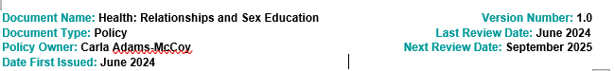

Jigsaw, the mindful approach to PSHE, provides a programme which offers us a comprehensive, carefully thought-through Scheme of Work bringing consistency and progression to our students’ learning in this vital curriculum area. The overview of the programme can be seen on the school website.

This also supports the “Personal Development” and “Behaviour and Attitude” aspects required under the Ofsted Inspection Framework, as well as significantly contributing to the school’s Safeguarding and Equality Duties, the Government’s British Values agenda and the SMSC (Spiritual, Moral, Social, Cultural) development opportunities provided for our young people.

Effective RSHE can make a significant contribution to the development of personal skills needed by pupils to establish and maintain relationships. RSHE will ensure children and young people are encouraged to understand the importance of stable, loving relationships, respect, love, and care. It also enables young people to make responsible and informed decisions about their health and wellbeing.

RSHE will be approached through evidence-based, best practice principles to ensure the highest impact on improving pupil health, wellbeing, safeguarding and lifelong outcomes. The following principles are based on research evidence, supported by a wide range of leading organisations including the NSPCC, Barnardo’s, The Children’s Society and education unions. They are also supported by a number of MPs and Lords:

Principles of effective RHSE

RSHE provision at Brinksway School:
Is an identifiable part of our school curriculum, which has planned, timetabled lessons across all the Key Stages.
Is taught by staff regularly trained in RSHE (with expert visitors invited in to enhance and supplement the programme, where appropriate).
Works in partnership with parents and carers, informing them about what their children will be learning and how they can contribute at home.
Delivers lessons where pupils feel safe and encourages participation by using a variety of teaching approaches with opportunities to develop critical thinking and relationship skills.
Is based on reliable sources of information, including about the law and legal rights, and distinguishes between fact and opinion.
Promotes safe, equal, caring and enjoyable relationships and discusses real-life issues appropriate to the age and stage of pupils, including friendships, families, consent, sexual harassment, relationship abuse, sexual exploitation and safe relationships online.
Gives a positive view of human sexuality with honest and medically accurate information so that pupils can learn about their bodies and sexual and reproductive health in ways that are appropriate to their age and maturity.

Gives pupils opportunities to reflect on their values and influences (such as from peers, media, faith and culture) that may shape their attitudes to relationships and sex and nurture respect for different views.

Includes learning about how to get help and treatment from sources such as the School Health Service and other health and advice services including reliable information online.
Fosters equality, including LGBT+ (lesbian, gay, bisexual, trans) equality and challenges all forms of discrimination in RSHE lessons and in everyday school life.

Meets the needs of all pupils with their diverse experiences including those with special educational needs and disabilities.
Seeks pupils’ views about RSHE so that teaching can be made relevant to their real lives and assessed and adapted as their needs change.

Entitlement and equality of opportunity

All children are entitled to access a broad and balanced curriculum delivered in an age and stage appropriate manner. Teachers will include a range of teaching styles and groupings to allow all children to make progress. Every child will be given opportunity to develop their skills independently and in groups, enhancing their own confidence and self–esteem.

We actively celebrate the diversity of our pupils, their families and the wider whole-school community. RSHE will always be taught in a non-judgemental, non -biased and fully inclusive manner through clear, impartial, scientific information as well as covering the law to ensure all pupils have equal access to our RSHE curriculum. We do not use RSHE as a means of promoting any form of sexual orientation over another.

Thorough consultation, continual assessment and regular reviews of the curriculum we ensure that we continually recognise and respect pupils’ different abilities, levels of maturity, personal circumstances (including gender identity, faith or culture and that of their family, friends and the wider whole-school community) in accordance with the school’s inclusion policy.

Teaching and learning

The RSHE programme will be led by Joshua Hallam, RSHE will be taught by Joshua Hallam in the secondary formal school, form tutors in the formal primary school, the area lead in the formal 6th form, and by form tutors in the semi-formal curriculum and supported by HLTA’s, TA’s, our swift team, therapy team, school council, external visitors including nurses and Hazel our school police education officer. All staff involved in the delivery of RSHE have received specialist training to ensure that pupils receive clear and consistent approaches to RSHE throughout their time at Brinksway School School. Whole staff and individual training needs will be identified through the school’s self-evaluation process and staff appraisal.

On occasion external visitors, experts and agencies may be invited to contribute to the delivery of RSHE to enhance delivery of these subjects, bringing in specialist knowledge and different ways of engaging with children and young people. When this happens, our school will:
Check the visitor or visiting organisation’s credentials.
Ensure the teaching delivered by the visitor fits with our planned programme and our published policy.
Discuss the detail of how the visitor will deliver their sessions and ensure that the content is age-appropriate and accessible for the pupils.
Ask to see in advance the materials visitors will use as well as a lesson plan so that collectively we can ensure it meets the full range of pupils’ needs (e.g. special educational needs).

Agree how confidentiality will work in any lesson and that the visitor understands how safeguarding reports should be dealt with in line with our school’s policy.
Arrange for the visitor to be supervised/supported by a member of school staff at all times.
Monitor and evaluate the visitor input to inform future planning.

RSHE will be taught through a range of teaching methodologies, including storytelling, drama, role play, discussions, individual private reflection, quizzes and fact finding, value spectrums, debating, independent research and artistic presentations etc. This

wide range of teaching strategies promotes engagement by all pupils, irrespective of preferred learning styles.

Curriculum

The elements of the RSHE curriculum are a statutory requirement to teach to meet Relationships and Sex Educa on (RSE) and Health Educa on, statutory from September 2020
and The Equalities Act, 2010.

RSHE will be taught through a ‘spiral curriculum’. This approach means that pupils will gain knowledge, develop values and acquire skills gradually by re-visiting core themes to build on prior learning. RSHE will support the school’s commitment to safeguard pupils through an age-appropriate curriculum that prepares them to live safely in the modern world.

Our intended RSHE curriculum is detailed below but may vary in response to emerging issues and to reflect the rapidly changing world in which our pupils are living and learning. If this is the case, parent/carers will be provided with appropriate notice before the amended programme is delivered. Where possible the curriculum will be complemented by themed assemblies, topic days and cross curricular links.

Whole-school approach

The Jigsaw Programme covers all areas of PSHE including statutory RSE and Health Education. The table below gives the learning theme of each of the six Puzzles (units) and these are taught across the school; the learning deepens and broadens every year.

Year/ | Being Me in My | Celebrating | Dreams and | Healthy Me | Relationships | Changing me
Age | World | Difference | Goals | Healthy Me | Relationships | Changing me
Ages | Self-identity | Identifying talents Being | Challenges | Exercising bodies Family life Friendships |  | bodies Respecting my body
3-5 | Understanding | special Families Where | Perseverance Goal- | Physical activity | Breaking friendships Falling | Growing up Growth and
 | feelings Being in a | we live Making friends | setting Overcoming | Healthy food | out Dealing with bullying Being change Fun and fears
 | classroom Being | Standing up for yourself | obstacles Seeking | Sleep Keeping | a good friend | Celebrations
 | gentle Rights and |  | help Jobs Achieving | clean Safety
 | responsibilities |  | goals
Ages | Feeling special and | Similarities and | Setting goals | Keeping myself | Belonging to a family Making | Life cycles – animal and
5-6 | safe Being part of a | differences | Identifying | healthy Healthier | friends/being a good friend | human Changes in me
 | class Rights and | Understanding bullying | successes and | lifestyle choices | Physical contact preferences | Changes since being a baby
 | responsibilities | and knowing how to deal achievements |  | Keeping clean | People who help us Qualities | Differences between
 | Rewards and feeling with it Making new |  | Learning styles | Being safe | as a friend and person Self- | female and male bodies
 | proud | friends Celebrating the | Working well and | Medicine | acknowledgement Being a | (correct terminology)
 | Consequences | differences in everyone | celebrating | safety/safety with good friend to myself |  | Linking growing and
 | Owning the Learning |  | achievement with a | household items | Celebrating special | learning Coping with
 | Charter. |  | partner Tackling | Road safety | Relationships | change Transition
 |  |  | new challenges | Linking health
 |  |  | Identifying and | and happiness
 |  |  | overcoming
 |  |  | obstacles Feelings
 |  |  | of success
Ages | Hopes and fears for Assumptions and |  | Achieving realistic | Motivation | Different types of family | Life cycles in nature
6-7 | the year Rights and | stereotypes about | goals Perseverance | Healthier choices Physical contact boundaries |  | Growing from young to old
 | responsibilities | gender Understanding | Learning strengths | Relaxation | Friendship and conflict SecretsIncreasing independence
 | Rewards and | bullying Standing up for | Learning with others Healthy eating |  | Trust and appreciation | Differences in female and
 | consequences Safe self and others Making |  | Group co-operation and nutrition |  |  | male bodies (correct



 | and fair learning |  | new friends Gender | Contributing to and |  | Healthier snacks | Expressing appreciation for | terminology) Assertiveness
 | environment |  | diversity Celebrating | sharing success |  | and sharing food | special relationships | Preparing for transition
 | Valuing |  | difference and remaining
 | contributions |  | friends
 | Choices
 | Recognising
 | feelings
Ages | Setting personal |  | Families and their | Difficult challenges |  | Exercise Fitness | Family roles and | How babies grow
7-8 | goals Self-identity |  | differences Family | and achieving |  | challenges Food | responsibilities Friendship and Understanding a baby’s
 | and worth Positivity conflict and how to |  |  | success Dreams |  | labelling and | negotiation Keeping safe | needs Outside body
 | in challenges Rules, manage it (child-centred) and ambitions New |  |  |  |  | healthy swaps | online and who to go to for | changes Inside body
 | rights and |  | Witnessing bullying and | challenges |  | Attitudes towards help Being a global citizen |  | changes Family
 | responsibilities |  | how to solve it | Motivation and |  | drugs Keeping | Being aware of how my | stereotypes Challenging my
 | Rewards and |  | Recognising how words | enthusiasm |  | safe and why it’s | choices affect others | ideas Preparing for
 | consequences |  | can be hurtful Giving and | Recognising and |  | important online | Awareness of how other | transition
 | Responsible |  | receiving compliments | trying to overcome |  | and off line | children have different lives
 | choices Seeing |  |  | obstacles |  | scenarios | Expressing appreciation for
 | things from others’ |  |  | Evaluating learning |  | Respect for | family and friends
 | perspectives |  |  | processes Managingmyself and others
 |  |  |  | feelings Simple |  | Healthy and safe
 |  |  |  | budgeting |  | choices
Ages | Being part of a class Challenging |  |  | Hopes and dreams |  | Healthier | Jealousy Love and loss | Being unique Having a baby
8-9 | team Being a school assumptions Judging by |  |  | Overcoming |  | friendships GroupMemories of loved ones |  | Girls and puberty
 | citizen Rights, |  | appearance Accepting | disappointment |  | dynamics | Getting on and Falling Out | Confidence in change
 | responsibilities and |  | self and others | Creating new, |  | Smoking Alcohol | Girlfriends and boyfriends | Accepting change
 | democracy (school |  | Understanding | realistic dreams |  | Assertiveness | Showing appreciation to | Preparing for transition
 | council) Rewards |  | influences | Achieving goals |  | Peer pressure | people and animals | Environmental change
 | and consequences |  | Understanding bullying | Working in a group |  | Celebrating inner
 | Group decision- |  | Problem-solving | Celebrating |  | strength
 | making Having a |  | Identifying how special | contributions


 | voice What | and unique everyone is | Resilience Positive
 | motivates | First impressions | attitudes
 | behaviour
Ages | Planning the | Cultural differences and | Future dreams The | Smoking, | Self-recognition and self-worth Self- and body image
9-10 | forthcoming year | how they can cause | importance of | including vaping | Building self-esteem Safer | Influence of online and
 | Being a citizen | conflict Racism Rumours money Jobs and |  | Alcohol. | online communities Rights and media on body image
 | Rights and | and name-calling Types | careers Dream job | Alcohol and anti- | responsibilities online. | Puberty for girls Puberty for
 | responsibilities | of bullying Material | and how to get there social behaviour |  | Online gaming and gambling | boys Conception (including
 | Rewards and | wealth and happiness | Goals in different | Emergency aid | Reducing screen time Dangers IVF) Growing responsibility
 | consequences How Enjoying and respecting |  | cultures Supporting | Body image | of online grooming SMARRT | Coping with change
 | behaviour affects | other cultures | others (charity) | Relationships | internet safety rules | Preparing for transition
 | groups Democracy, |  | Motivation | with food Healthy
 | having a voice, |  |  | choices
 | participating |  |  | Motivation and
 |  |  |  | behaviour
Ages | Identifying goals for | Perceptions of normality Personal learning |  | Taking personal | Mental health Identifying | Self-image Body image
10-11 | the year Global | Understanding disability | goals, in and out of | responsibility | mental health worries and | Puberty and feelings
 | citizenship | Power struggles | school Success | How substances | sources of support Love and | Conception to birth
 | Children’s universal Understanding bullying |  | criteria Emotions in | affect the body | loss Managing feelings Power | Reflections about change
 | rights Feeling | Inclusion/exclusion | success Making a | Exploitation, | and control Assertiveness | Physical attraction Respect
 | welcome and | Differences as conflict, | difference in the | including ‘county | Technology safety Take | and consent
 | valued Choices, | difference as celebration world Motivation |  | lines’ and gang | responsibility with technology | Boyfriends/girlfriends
 | consequences and | Empathy | Recognising | culture Emotional use |  | Sexting Transition
 | rewards Group |  | achievements | and mental
 | dynamics |  | Compliments | health Managing
 | Democracy, having |  |  | stress

- voice Anti-social behaviour Role-modelling

Year/ | Being Me in My | Celebrating | Dreams and | Healthy Me | Relationships | Relationships
Age | World | Difference | Goals | Healthy Me | Relationships | Relationships
Year 7 | Unique me, differences Bullying, prejudice & |  | Celebrating | Stress and anxiety, | Characteristics of | Puberty changes,
(11- | & conflict. My | discrimination (positive success, identifying managing mental |  |  | healthy relationships, | Reproduction facts, FGM,
12) | influences, gateway | and negative) Equality | goals, employment, health, physical |  | consent. Relationships breast flattening/ironing.
 | emotions, belonging to Act, bystanders, |  | learning from | activity and mental | and change, emotions | Responsibilities of
 | a group, peer pressure, stereotyping, |  | mistakes, | health. Effects of | within friendships, | parenthood, IVF, types of
 | child on child abuse. | challenging influences, overcoming |  | substances, legal | child on child abuse. | committed relationships.
 | Online safety, sexting, | negative behaviour and challenges, |  | consequences. | Rights and | Media and self-esteem,
 | consequences, online | attitudes, | planning skills. Safe Nutrition and sleep. |  | responsibilities, being | self-image, brain changes
 | legislation | assertiveness | & unsafe choices, | Vaccination, | discerning, | in puberty, factors
 |  |  | substances, gangs, | importance of | assertiveness, sexting | affecting moods, sources
 |  |  | knives, exploitation. information on |  |  | of help and support
 |  |  | Emergency first aid | making health
 |  |  |  | choices
Year 8 | Self-identity, | Positive change made | Long-term goals, | Long-term physical | Positive relationship | Types of close intimate
(12- | influences, family and | by others, how positive skills, |  | health, | with self, social media | relationships, physical
13) | identity. Stereotypes, | behaviour affects | qualifications, | responsibility for | and relationship with | attraction, love. Legal
 | personal beliefs and | feelings of wellbeing. | careers, Money and | own health. Dental | self, negative self-talk. | status of relationships,
 | judgements. Managing | Social injustice, | happiness. Ethics | health, stress | Managing a range of | behaviours in healthy and
 | expectations, first | inequality, community | and mental | triggers and help | relationships, child on | unhealthy romantic
 | impressions, respect | cohesion and support, | wellbeing, | tips, substances | child abuse, personal | relationships,
 | for the beliefs of | multi-culturalism, | budgeting, variation | and mood. | space. Online | pornography, sexuality,
 | others. Marriage, | diversity, race and | in income, positive | Legislation | etiquette, online | alcohol and risky
 | protected | religion. Stereotypes, | and negative impact associated with |  | privacy, bullying and | behaviour
 | characteristics. Active | prejudice, LGBT+ | of money. Online | substances, | personal safety. Social
 | listening | bullying, child on child | safety and legal | exploitation and | media issues and the


 |  | abuse, hate crimes. | responsibilities, | substances, county | law, coercion,
 |  | Fear & emotions, stand gambling issues |  | lines. Medicine and | unhealthy balance of
 |  | up to bullying, the |  | vaccinations. | power in relationships,
 |  | golden rule. Organ and |  |  | sources of support
 |  | blood donation
Year 9 | Perceptions about | Protected | Personal strengths, | Misperceptions | Healthy relationships, | Mental health stigma,
(13- | intimate relationships, | characteristics, | health goals, SMART about young |  | power and control in | triggers, support
14) | consent. Sexual | Equality Act, phobic | planning. The world | peoples’ health | intimate relationships, | strategies, managing
 | exploitation, peer | and racist language. | of work. Links | choices, physical | risk in intimate | emotional changes,
 | approval, child on child Legal consequences of between body |  |  | and psychological | relationships, | resilience and how to
 | abuse, grooming, | bullying and hate | image and mental | effects of drugs and importance of sexual |  | improve it, reflection on
 | radicalization, county | crime, sexism, ageism, health. Non- |  | alcohol. Alcohol andconsent, assertiveness importance of sleep in
 | lines. Risky | positive and negative | financial dreams | the law, alcohol and skills, sex and the law, |  | relation to mental health,
 | experimentation, | language, banter, child and goals. Mental |  | drug poisoning, | pornography and | reflection on changes,
 | positive and negative | on child abuse, | health and ill health, addiction, smoking, |  | stereotypes, | benefits of relaxation
 | self-identity, groups, | bullying in the | media | vaping, drug | contraception choices,
 | influences, social | workplace. Direct and | manipulation, self- | classification, | age of consent, family
 | media. Abuse and | indirect discrimination, harm, self-esteem, |  | supply and | planning,
 | coercion, coercive | harassment, | stigma, anxiety | possession | consequences of
 | control. | victimisation. | disorders, eating | legislation. | unprotected sex, STIs,
 |  | Prejudice, | disorders, | Emergency | support and advice
 |  | discrimination and | depression | situations, first aid, | Services
 |  | stereotyping |  | CPR, substances
 |  |  |  | and safety, sources
 |  |  |  | of advice and
 |  |  |  | support
Year | Human rights, societal | Equality in the | Impact of physical | improving health, | sustaining long-term | impact of societal change
10 | freedom, | workplace, in society, | health in reaching | mental health, | relationships, intimacy, on young people, role of
(14- | understanding safety in in relationships, |  | goals, relationships | sexual health, | healthy relationship | media on societal change,

15) UK and beyond. Ending Equality act 2010, and reaching goals. blood-borne with self, attraction, reflection on change so far



 | relationships safely, | vulnerable groups | Resilience, work-life infections, self- |  | love, lust. Relationship and how to manage it
 | stages of grief, loss and including disability and balance, |  |  | examination. Diet | choices, ending | successfully. Decision-
 | bereavement. Social | hidden disability, | connections and | and long-term | relationships safely, | making, sexual identity,
 | media and culture, use workplace |  | impact of mental | health, misuse of | consequences of | gender, spectrum of
 | of online data, threats | expectations, rights | health. Balanced | prescription drugs, | relationships ending | sexuality. Stereotypes in
 | to online safety, online and responsibilities, |  | diet, vital organs, | substances and the | e.g bullying, child on | romantic relationships,
 | identity. Assessing and power and control in |  | blood donation, | body. Common | child abuse, revenge | sexual identity and risk,
 | managing risk, the law | relationships, coercive | benefits of helping | mental health | porn, grief cycle, | physical and emotional
 | and social media. | control, benefits of | others. Online | disorders, positive | impact on family. | changes, family change,
 | Positive and negative | multi-cultural | profile and impact | impact of | Understanding love, | sources fo support.
 | relationships | societies, Equity | on future goals and | volunteering. | fake news,
 |  | equality and inequality, employability. |  | Common threats to | pornography.
 |  | my health. |  | health including
 |  |  |  | chronic disease.
 |  |  |  | Epidemics, misuse
 |  |  |  | of antibiotics, organ
 |  |  |  | donation, stem
 |  |  |  | cells
Year | Becoming an adult. Age |  | Anxiety, solution | Managing anxiety | Stages of intimate
11 | limits and the law |  | focused thinking, | and stress, exam | relationships, positive
(15- | relationships and the |  | sleep, relaxation, | pressure, | and negative
16) | law, consent, coercive |  | aspiration on; | concentration | connotations of sex.
 | control, child on child |  | career, finances, | strategies, work-life | Spectrum of gender
 | abuse, domestic |  | budgeting, | balance. Sexual | and sexuality, LGBT
 | abuse, honour-based, |  | borrowing, | health, hygiene, | right and protection
 | violence, arranged and |  | relationships. Skills | self-examination. | under the Equality Act,
 | forced marriages The |  | identification, | STIs, sexual | coming out challenges,
 | Equality Act 2010. The |  | realistic goals, | pressure, fertility | LGBT media
 | law on internet use and |  | gambling, financial | issues, | stereotypes. Child on
 | pornography, social |  | pressure, debt, | contraception, | child abuse, power




media concerns, | dream jobs, skills | consent. Pregnancy | control and sexual
sexting keeping safe. | set, employment, | choices including | experimentation.
Emergency situations, | education and | adoption, abortion, | Forced marriage,
key advice, first aid, | training options. | bringing up a baby, | honour-based
scenarios and | Long term | financial | violence, FGM and
consequences | relationship dreams implications. |  | other abuses, hate
 | and goals, parenting Identifying a range |  | crime, sources of
 | skills and | of risks including | support.
 | challenges. | rape and strategies
 | Resilience, what to | for staying safe.
 | do when things go | Expectations in
 | wrong | relationships

At Brinksway School School we allocate 45mins to PSHE each week in order to teach the PSHE knowledge and skills in a developmental and age-appropriate way.

These explicit lessons are reinforced and enhanced in many ways:

- assemblies and collective worship,

- praise and reward system,

- Learning Charter,

- through relationships student to student, adult to student and adult to adult across the school.

- We aim to ‘live’ what is learnt and apply it to everyday situations in the school community.

- Class teachers/ a dedicated PSHE Team deliver the weekly lessons.

- Each lesson has a 45 minute timetabled slot each week.

Assessment

Pupils’ learning will be assessed at the end of every topic to ensure that pupils are making sufficient progress to build on prior teaching and learning and that teaching strategies and resources remain relevant and effective. Assessment activities will be implicit, forming part of a normal teaching activity to ensure that pupils do not feel under pressure and will include self-assessment tasks that will confirm pupils understanding of the topics. The evaluation of teaching and learning assessments will be shared with pupils and parents as appropriate.

The quality of RSHE teaching and learning will be monitored through RSHE learning walks, team teaching and informal drop-ins conducted by subject leads and/or members of the senior leadership team. The observations and findings of which will be used to identify and inform future staff training needs. We record breadth of coverage using Gridmaker. Progress is also recorded using Earwig, our school assessment tool.

Responding to pupils’ questions

There will always be sensitive and controversial issues within the subjects of RSHE. These may be a matter of age and stage appropriateness or contrasting personal beliefs including those originating from faith perspectives and culture. We believe that children are best educated and protected from harm when they are provided with a safe and supportive space to discuss issues openly within the framework of a class working agreement. At the end of every lesson, pupils will be provided with an opportunity to ask questions in an open setting and will also be provided with an opportunity to raise anonymous questions through the use of an anonymous ‘ask-it-basket’. Teachers will answer questions as fully as they feel age and stage appropriate based on the level of knowledge demonstrated by pupils during the lesson. Teachers may delay answering a pupil’s question if they need time to consult with a colleague or the school leadership team to construct an appropriate answer.

Teachers can refuse to answer a question that they feel is inappropriate and will never answer personal questions about their own body, personal circumstances or lifestyle choices. If a teacher does not answer a question, the pupil will have the reasons clearly explained and the teacher will work with the pupil to identify suitable sources of information where they can obtain an answer to their question. This may include encouraging the pupil to ask a parent/carer or trusted adult at home.

Safeguarding, reports of abuse and confidentiality

The school’s responsibility to safeguard pupils through a curriculum that prepares them to live safely in the modern world will remain central to our curriculum content, teaching methodologies and supporting resources.

At the beginning of RSHE teaching the class will discuss and create a ‘working agreement’. Confidentiality will be included within this agreement so pupils are clear of the limits of confidentiality that can be guaranteed by a teacher.

Distancing techniques such as the use of characters within RSHE avoids pupils feeling under pressure to participate or disclose information beyond that which is appropriate or feels comfortable. This strategy makes RSHE more accessible to all pupils including those who may have experienced unhealthy relationships and/or abuse.

Teachers will signpost pupils to information relevant to the topic being taught to ensure safe sources of information, advice and guidance are provided. Teachers will also work closely with the school’s pastoral system to advise on topic coverage, using trusted, high quality local resources, so that the school can be responsive to pupil’s pastoral needs and safeguarding arrangements can be actioned efficiently if required.

Teachers will understand that an open forum to discuss potentially sensitive issues can lead to increased safeguarding reports. Children will be made aware of the processes to enable them to raise their concerns or make a report and how any report will be handled. This will also include processes when they have a concern about a peer or friend.

In line with the document Keeping Children Safe in Education (KCSIE), all staff
are aware of what to do if a child tells them that they are being abused or
neglected, including referring to being involved (or being likely to be involved) in sexual
activity. Staff are also aware of need to manage the requirement to maintain an
appropriate level of confidentiality. This means only involving those that need to be
involved, such as the Designated Safeguarding Lead and children’s

social care. A member of staff will never promise a child that they will not tell anyone about a report of abuse, as this is not in the best interests of the child.

Involving parents and carers

We believe that parents and carers are the primary educators of their children in RSHE and that RSHE is most effective when it is collaboration between school and home. We therefore wish to build a positive and supporting relationship with parents and carers of children and young people at our school through mutual understanding, trust and cooperation.

The school will provide support to parents and carers through an annual workshop which provides a valuable opportunity to develop awareness of emerging RSHE topics, meet RSHE teachers and review the resources being used as well as consider ways to build on the learning at home, fostering strong channels of communication between parents/carers and their children. The school also operates an open -door policy enabling parents to discuss RSHE at relevant times throughout the school year.

The vast majority of RSHE is compulsory. There is no right to withdraw from Relationships Education or Health Education. Parents and carers are only able to request that their child is excused from Sex Education, taught outside of the national curriculum for science. Parents and carers cannot withdraw their children from sex education taught in science. If a parent wishes their child to be excused from some or all of Sex Education taught as part of RSHE, they should discuss this with the headteacher, making clear which aspects of the programme they do not wish their

child to participate in. The head teacher will outline to parents/carers the benefits of receiving this important education and any detrimental effects that withdrawal might have on the child. This could include any social and emotional effects of being excluded as well as the likelihood of the child hearing their peers’ version of what was said in the classes rather than what was directly said by the teacher (although detrimental effects may be mitigated if the parents/carers propose to deliver sex education to their child at home instead). Once a decision has been made, parents/carers must inform the school in writing stating their reasons as to why they would like their child withdrawn.

Once these discussions have taken place, except in exceptional circumstances, our school will respect a parent/carers’ request to have their child excused from sex education up to and until three terms before the child turns 16. After that point, if the child wishes to receive sex education, rather than be withdrawn, the school should make arrangements to provide the child with sex education during one of those terms. The school will document this process.

This process is the same for pupils with SEND. However, there may be exceptional circumstances where the head teacher may want to take a pupil’s specific needs arising from their SEND into account when making this decision.

If a pupil is excused from sex education, the school will ensure that the pupil receives appropriate, purposeful education during the period of withdrawal.

Links to other school policies and curriculum

This policy complements the following policies:
Anti-bullying E-safety
Equality Inclusion PSHE

Safeguarding
Teaching and learning.

Review date

The local governing body monitors the impact of RSHE on an annual basis. The governors give serious consideration to any comments, consultation and evidence of impact.

Consultation with pupils will be conducted on a regular basis to support with reviewing the curriculum to ensure it remains responsive to emerging needs and the policy updated accordingly.

This policy will be reviewed every year or sooner if the RSHE curriculum is amended, for example in response to emerging themes, changing pupil needs or introduction of new legislation and guidance. The next review date of this policy is currently set for September 2024.



We are part of the Outcomes First Group
Family, by working together we will build

Incredible futures by empowering
children, young people and adults In the
UK to be happy and make their way in
the world


